How to use the post-image.sh

the file post-image.sh
will accept parameters from the menuconfig from:

System-configuration->

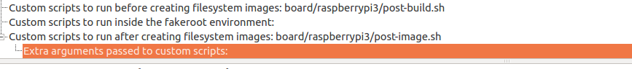
Extra argument passed to custom script

case "${2}" in
--add-pi3-miniuart-bt-overlay)
if ! grep -qE '^dtoverlay=' "${BINARIES_DIR}/rpi-firmware/config.txt"; then
echo "Adding 'dtoverlay=pi3-miniuart-bt' to config.txt (fixes ttyAMA0 serial console)."
cat << __EOF__ >> "${BINARIES_DIR}/rpi-firmware/config.txt"

# fixes rpi3 ttyAMA0 serial console
dtoverlay=pi3-miniuart-bt

The above example , add the pi3-miniuart-bt overlay in case the flag
--add-pi3-miniuart-bt-overlay was specified

I removed it here because I dont want to enable this overlay.

